CS3235 Course Project Research Paper
RV University Bengaluru
SiteSight AI Evidence Grounded Construction Inspection with PPE Monitoring and Human Verified Reporting
Madhur Maru 1RVU23CSE246 Mohammad Arbab Mohsin 1RVU23CSE276 Mohamed Junaid Irfan 1RVU23CSE275
School of Computer Science and Engineering RV University Bengaluru India
Abstract—Construction inspection records are commonly assembled from disconnected photographs, manual notes and delayed safety reviews. SiteSight AI is an academic full-stack prototype that converts uploaded construction images and short videos into traceable inspection records while preserving human authority over safety and progress conclusions. The system combines a COCO person detector with PPE-specific YOLOv8 weights, normalised bounding boxes, bounded video-frame sampling and a spatial association policy that classifies helmet and vest observations as present, possibly missing or unable to assess. A durable queue persists processing state and makes retries idempotent. Engineers add observations, update milestones and approve immutable PDF reports; project questions retrieve authorised report snapshots and may use a server-side Groq model with citation and numerical validation. In a nine-image held-out audit at confidence 0.5 and IoU 0.5, helmet precision and recall were 0.667 and 0.833, while no-helmet precision and recall were 0.750 and 0.429. Vest performance was poor, and a four-worker association audit produced six correct outcomes from eight component labels. The results demonstrate a coherent evidence-to-report workflow, but the small dataset does not support a production-accuracy claim. SiteSight AI therefore treats machine output as a review aid rather than an autonomous safety decision.
Keywords—construction inspection, object detection, personal protective equipment, evidence grounding, human verification, progress monitoring

1 Introduction
Construction teams collect large volumes of photographs and short videos, yet those files often remain weakly connected to zones, milestones, review decisions and final reports. Manual review is time consuming, progress claims can become detached from their supporting evidence, and PPE observations may be reported without clear distinction between an algorithmic proposal and an engineer's decision. Research has shown that visual monitoring can support progress recognition and PPE detection, but many studies address a single task or assume controlled capture conditions [1]-[8].
SiteSight AI addresses this workflow rather than claiming a universally accurate detector. It connects project setup, inspection upload, computer-vision analysis, human observation, verified progress, report approval and PDF export. The research questions are whether these stages can preserve evidence traceability and whether generated language can remain grounded in authorised records.
The contributions of this work are:
- A working inspection-to-approved-report pipeline for images and sampled video, backed by persistent jobs and private evidence storage.
- A conservative spatial-v3 association policy that links PPE candidates to worker head and torso regions while returning unknown for small, clipped or occluded observations.
- An evidence-grounded reporting and Q&A layer that validates record ownership, citations and numerical claims before generated wording is shown.
- A reproducible small-sample evaluation that reports class-aware IoU-matched precision and recall separately from worker-PPE association outcomes.
The remainder of this paper reviews related monitoring approaches, defines the task and dataset, describes the system, presents the prototype and evaluation, and discusses limitations and responsible use.

2 Related Work and Literature Review
Photo-based progress monitoring has moved from 3D or 4D registration toward learned activity and component recognition. Prior work converted daily photographs into progress evidence but still depended on coverage and registration [1], while integrated and interior pipelines remained sensitive to project variation, clutter and similar work states [2]-[4]. SiteSight therefore treats visual comparison as a reviewer observation rather than an automatic completion estimate.
PPE research shows that defined classes can be detected in near real time, but lighting, crowding, class imbalance and worker-equipment association remain difficult [5]-[8]. Zero-shot and vision-language approaches broaden flexibility but are not reliable enough for autonomous enforcement and require evidence grounding [9], [10]. SiteSight uses scoped relational retrieval, following the grounding principle of RAG [11], because its implemented questions concern structured inspection records.
Ref. | Method | Dataset | Contribution | Limitation
[1] | 4D BIM and unordered photos | Daily site photos | Structured progress evidence | Requires registration and coverage
[2] | Integrated CV pipeline | Construction imagery | Recognition and measurement | Limited cross-project generalisation
[3] | Deep learning for interiors | Interior site images | Activity and component recognition | Clutter and similar work states
[5] | Fast PPE detector | Construction workers | Near-real-time PPE detection | Limited contextual understanding
[6] | YOLO helmet detection | Construction imagery | Practical helmet compliance detector | Crowding and lighting sensitivity
[7] | Multi-class PPE detection | PPE image dataset | Beyond helmet-only monitoring | Class imbalance and association gap
[9] | Zero-shot OWLv2 | 5,210 hardhat images | Reported AP 0.6493 | Not reliable for enforcement
[10] | VLM safety reasoning | Construction scenes | Open-ended hazard guidance | Hallucination and prompt sensitivity
Table 1 Summary of selected related work
The research gap is therefore integration: existing work validates individual building blocks, but fewer systems combine temporal inspection records, conservative PPE association, engineer-entered progress, immutable approvals and citation-checked language output in one traceable workflow.

3 Problem Formulation
For an inspection I, the input is a set of images or a short video V, project and zone metadata, capture time, optional viewpoint and reviewer notes. Video V is transformed into a bounded set of frames F={f1,...,fk}. For each image or frame, the detector produces D={(ci,si,bi)}, where ci is a supported class, si is confidence and bi=[x,y,w,h] is a normalised box. The application maps raw classes to worker, helmet, vest, no-helmet and no-vest, then associates equipment candidates with worker-specific head and torso regions.
The output is not a safety verdict. Each worker-component pair is marked present, possible missing or unable to assess. Human observations and progress updates remain separate from model proposals. Approved reports freeze authorised, reviewed facts, and project Q&A must cite accessible records or return insufficient evidence.

4 Dataset

4.1 Data Source and Description
Evaluation uses nine held-out Construction Site Safety images distributed through Hugging Face and originating from Roboflow Universe under CC BY 4.0 [12]. Classes are worker, helmet, vest, no-helmet and no-vest. A separate five-image count audit covers visible PPE, missing PPE, occlusion, distance, crowding, edge clipping and poor lighting.
https://universe.roboflow.com/roboflow-universe-projects/construction-site-safety

4.2 Data Preprocessing
Uploads are decoded and validated as JPEG, PNG or WebP, limited to 40 megapixels and 100 MB per inspection. EXIF orientation is normalised, images are converted to RGB and boxes are stored as normalised coordinates. Videos are checked with ffprobe, limited to 60 seconds and 4K, and sampled uniformly into at most 12 timestamped frames.

4.3 Data Split
No model training was performed within this project. The detector weights are pretrained, and the audit uses held-out test images from the source dataset. Consequently, there is no project-specific train-validation-test split and no claim that the audit is independent of the detector's broader training domain. The small and sparsely annotated sample measures agreement with supplied boxes, not general construction-site accuracy.

5 Proposed Methodology

5.1 System Architecture
Figure 1 summarises the pipeline. Next.js stores authenticated private evidence and a persistent SQL job. A leased Node worker invokes FastAPI inference, then validates and transactionally upserts stable evidence-scoped outputs. Failed jobs remain diagnosable and retryable.
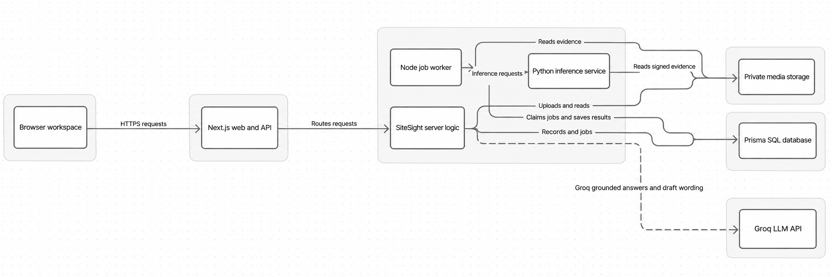
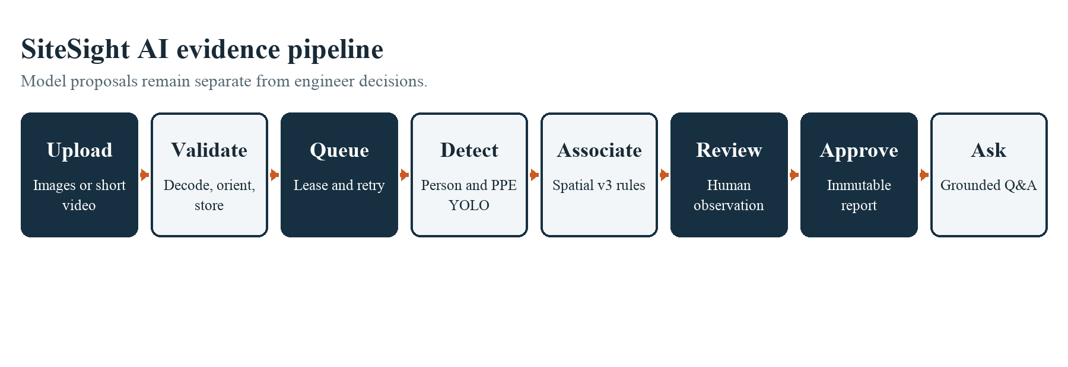
Figure 1 SiteSight AI evidence processing architecture

5.2 Computer Vision Models
The detector combines PPE Compliance YOLOv8n with a separate YOLOv8n COCO person model because the PPE file's Person coverage was inconsistent. It maps Hardhat, Safety Vest, NO-Hardhat and NO-Safety Vest, stores weight hashes, and uses version ppe-a427495+coco-v8.3.0.
Spatial-v3 assigns helmet candidates to the upper 25% of a worker box and vest candidates to the 20%-68% torso region. It returns unable to assess for workers that are too small, clipped, low confidence or more than 45% occluded. Positive PPE yields present; assessable absence yields possible missing. Negative-class detections are supporting evidence, never automatic confirmation.

5.3 Evidence Grounded Language Model
The language layer uses Groq's OpenAI-compatible API with openai/gpt-oss-20b. General chat receives no project records. Record questions retrieve authorised report snapshots and request answer text plus exact source identifiers; the server then validates ownership, evidence links and every numerical claim. Conversation context remains in browser memory and clears on refresh.
This is retrieval-grounded generation [11] over relational records rather than vector chunks. Provider failure is explicit, and deterministic excerpts are labelled. Generated wording cannot alter an approved report.

5.4 Training and Inference Configuration
The project does not fine-tune either detector or language model. Computer vision uses pretrained weights with confidence 0.5 for the reported audit and class-aware IoU matching at 0.5. The inference service runs on Python 3.11.16 with Ultralytics 8.4.193, FastAPI 0.135.1 and Pillow 12.1.1. Language requests use bounded input, a 3–60 second timeout, zero to two retries and 64–2400 output tokens. These bounds limit resource use but do not overcome provider quota or model incompatibility.

6 Prototype and Deployment

6.1 Prototype Description
The prototype provides project, inspection, progress, report, Q&A and settings routes. Reviewers browse images or sampled frames, filter overlays, zoom, inspect provenance and record an optional observation. Aggregate counts reduce review load while raw findings remain available for audit.
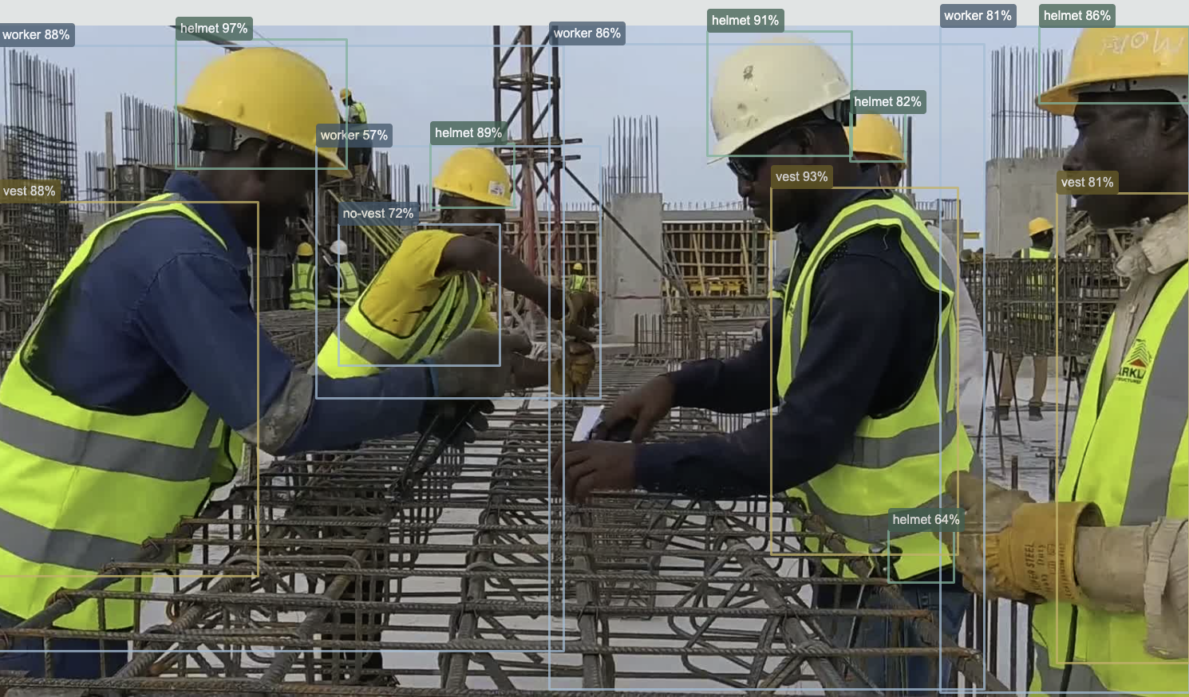
Figure 2 Construction evidence with worker and PPE overlays
Completing an inspection creates one draft linked to that inspection. Authorised users submit, approve and export an evidence-linked PDF. Viewers receive only approved snapshots and their linked media.
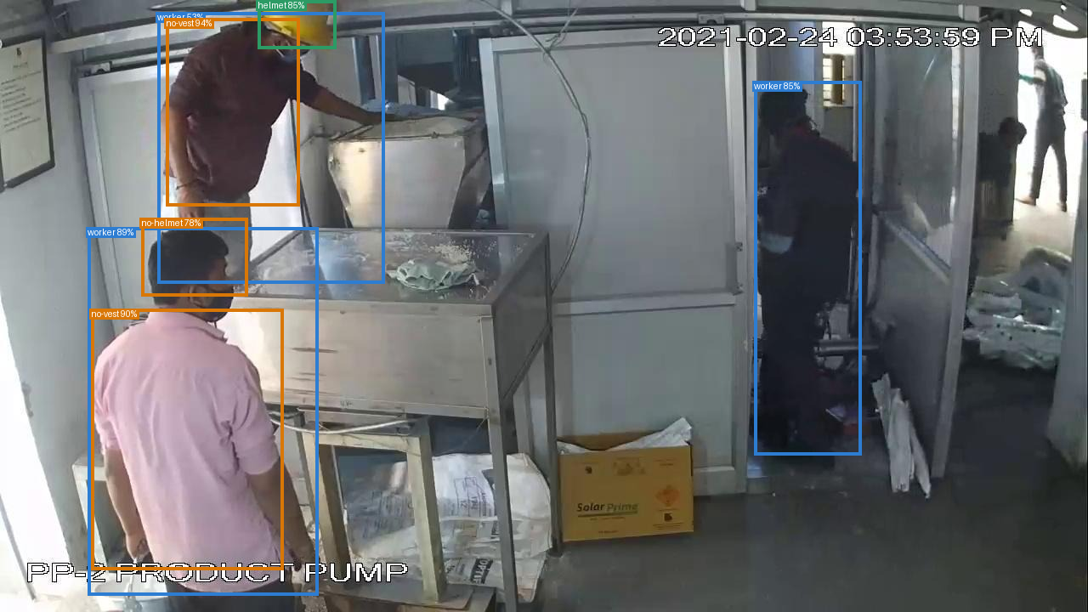
Figure 3 Real inference overlay showing worker and PPE class predictions

6.2 Local Deployment
The verified deployment runs locally with Next.js 16.4.3, React 19.3.1, Prisma 6.19.0, SQLite, private filesystem media, Node 22.22.2 and Python 3.11.16. FFmpeg samples video. PostgreSQL and S3-compatible adapters exist but were not part of the verified run.

6.3 Repository Structure
Directory | Contents
app | Pages, permission-aware API and inspection UI
lib | Queue, reports, grounding, storage and domain rules
worker | FastAPI inference, association and evaluation
prisma | SQLite schema, migrations and seed data
evaluation | Labels, source metadata and generated metrics
tests | Domain, grounding, permission and HTTP acceptance tests
docs | Architecture, models, deployment and verification evidence
Table 2 Repository structure

7 Experimental Setup

7.1 Implementation Environment
Verification used macOS, Python 3.11.16 and Node.js 22.22.2 with CPU-compatible Ultralytics inference. Reproducibility commands pin detector hashes and run association, domain, HTTP, browser, lint, type-check and production-build checks.

7.2 Evaluation Metrics
Predictions are confidence ordered and matched one-to-one to the highest-IoU unmatched ground-truth box of the same class at IoU >= 0.5. Precision=TP/(TP+FP), recall=TP/(TP+FN), and F1=2PR/(P+R). AP and mAP are not calculated. Association outcomes and unmatched count discrepancies are evaluated separately.

7.3 Baselines and Scope
The study does not compare newly trained architectures. Its practical baseline is a disconnected workflow in which photographs, detector outputs, reviewer notes and reports are handled separately. The evaluated contribution is the integrated pipeline around pinned pretrained models. Comparisons with published detector results are avoided because datasets, label coverage and deployment conditions differ.

8 Results and Analysis
Class | TP | FP | FN | Precision | Recall | F1
worker | 4 | 15 | 0 | 0.210 | 1.000 | 0.348
helmet | 10 | 5 | 2 | 0.667 | 0.833 | 0.741
vest | 0 | 7 | 1 | 0.000 | 0.000 | 0.000
no-helmet | 3 | 1 | 4 | 0.750 | 0.429 | 0.545
no-vest | 2 | 8 | 1 | 0.200 | 0.667 | 0.308
Table 3 Class-aware detection results at confidence 0.5 and IoU 0.5
Helmet detection produced TP=10, FP=5 and FN=2, yielding precision 0.667 and recall 0.833. No-helmet precision was 0.750 and recall 0.429. Worker recall was 1.000 against four labelled boxes, but 15 unmatched predictions reduced precision to 0.211; sparse annotations mean this is agreement with supplied labels, not exhaustive worker accuracy.
Vest performance was weakest: seven predictions were unmatched and one labelled vest was missed. The association audit matched four of four workers and six of eight component outcomes; the two errors called PPE missing for a poorly lit worker that human review labelled unable to assess.
A real upload completed private storage, queue processing, inference, annotated review, approval and PDF export. Retry created no duplicate detections or findings, and reviewer correction preserved original output. This verifies workflow integrity, not detector generalisation.

9 Discussion
The strongest result is traceability: every detection retains provenance, confidence, normalised geometry and association, while transactional upserts make retry safe. Approval freezes a report snapshot so later edits cannot silently rewrite it.
The results expose important limits. Sparse labels distort measured precision, vest detection is weak, and poor lighting affects association. Uniform video sampling may miss events, frame observations are not unique people, and imagery cannot certify engineering quality or exact completion. Progress remains engineer entered.
Language generation may reduce summarisation effort but introduces quota and hallucination risks. Retrieval precedes generation, stored notes are treated as untrusted, citations and numbers are validated, and drafts require approval.

10 Ethical Considerations and Responsible AI
Construction media can reveal identifiable workers, layouts and operations. Media is private, access is authorised, and connected downloads use short-lived URLs. The language provider receives bounded structured records rather than images, passwords or member details. Production use still needs consent, retention and privacy assessment.
Lighting, PPE colour, camera angle, crowding and domain shift can create bias. Unknown observations are excluded from compliance denominators, enforcement remains human, and model and dataset licences are recorded for deployment review.

11 Conclusion and Future Work
SiteSight AI demonstrates a persistent construction-inspection workflow that connects private evidence, computer vision, conservative PPE association, human observations, verified progress, immutable reports and grounded project Q&A. The real-image workflow and idempotent queue operate end to end, while the evaluation identifies both useful helmet performance and substantial limitations for vest detection, worker-label agreement and low-light association. The system's appropriate role is decision support: it organises and explains evidence, while engineers and safety officers determine what that evidence establishes.
Future work should expand independently labelled evaluation across sites and conditions, calculate AP and mAP on adequate ground truth, calibrate assessability, add video tracking without double counting, test PostgreSQL/S3 deployment, measure review time saved and evaluate citation entailment with human raters.

References
[1] M. Golparvar-Fard et al., "Automated progress monitoring using unordered daily construction photographs," J. Constr. Eng. Manage., 2015, doi: 10.1061/(ASCE)CP.1943-5487.0000205.
[2] J. Wang et al., "Vision-based framework for automatic progress monitoring," J. Constr. Eng. Manage., 2021, doi: 10.1061/(ASCE)CP.1943-5487.0000933.
[3] B. Ekanayake et al., "Computer vision-based interior construction progress monitoring," Autom. Constr., 2021, article S0926580521001564.
[4] W. Fang et al., "A fast end-to-end method for automatic interior construction progress monitoring," Eng. Appl. Artif. Intell., 2023, article S095219762300917X.
[5] Z. Wang et al., "Fast personal protective equipment detection for real construction sites," Sensors, vol. 21, no. 10, p. 3478, 2021.
[6] A. Hayat et al., "Deep learning-based automatic safety helmet detection in construction sites," Appl. Sci., vol. 12, no. 16, p. 8268, 2022.
[7] S. Ahmed et al., "Personal protective equipment detection: A deep-learning approach," Sustainability, vol. 15, no. 18, p. 13990, 2023.
[8] M. Elesawy et al., "Comparative analysis of YOLO models for PPE compliance," 2024. [Online]. Available: https://www.mdpi.com/2673-4117/5/1/19
[9] J. Choi and M. Greer, "Zero-shot detection and association of hardhats for increased construction safety," arXiv:2410.12225, 2024.
[10] M. Adil et al., "Using vision language models for safety hazard identification at construction sites," arXiv:2504.09083, 2025.
[11] P. Lewis et al., "Retrieval-augmented generation for knowledge-intensive NLP tasks," in Proc. NeurIPS, 2020.
[12] Keremberke, "Construction Safety Object Detection Dataset," Hugging Face Datasets. [Online]. Available: https://huggingface.co/datasets/keremberke/construction-safety-object-detection

Appendix Reproducibility and Disclosure
The repository includes migrations, seeds, pinned weight checksums, environment documentation, evaluation labels and commands for type checking, linting, unit, HTTP, browser and production-build checks. It is maintained as the course submission; no public repository URL was assigned for this draft.
AI-assisted tools were used during software development and preparation of this draft. The authors remain responsible for checking the implementation, experimental results, citations, interpretations and final submitted wording against university policy.

